*Case Study 1.1:***Strange persistent high: The importance to avoid occlusion** V.2.0



Here an incidence report to emphasize the high importance of doing what it takes to prevent occlusion (and to recognize it early, should one happen nevertheless):

Persistent high glucose despite very high iob

After a ~12:20 h lunch, I saw glucose rise, by 15:45 h, to 280 mg/dl, which is an extremely unusual level for me.

Insulin activity (thin yellow curve) had been high for over 2 hours already, and iob had risen to nearly 9 U by that time.

Searching for an explanation, I first saw that the infusion set was in place already 2 days. Indeed, at cannula change, plenty of blood showed in the old set (picture) and there was smell and humidity from insulin (pushed back out into the adhesive pad).

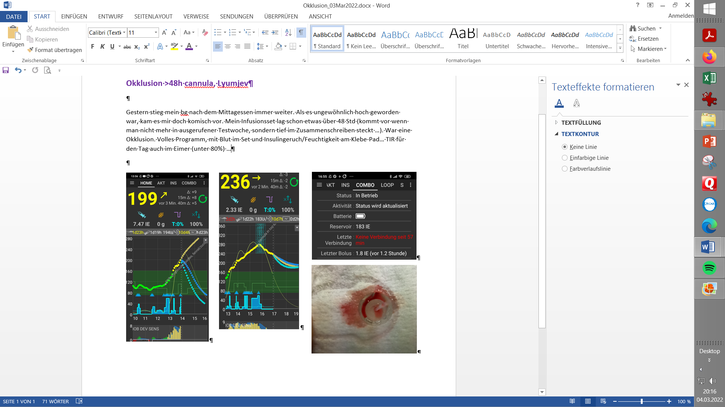

Around 16:00, the pump had stopped, too.

:

Fake iob led to a extreme **outlier in TDD** (54 U vs 39 avg,), and a very high fake carb deviation:

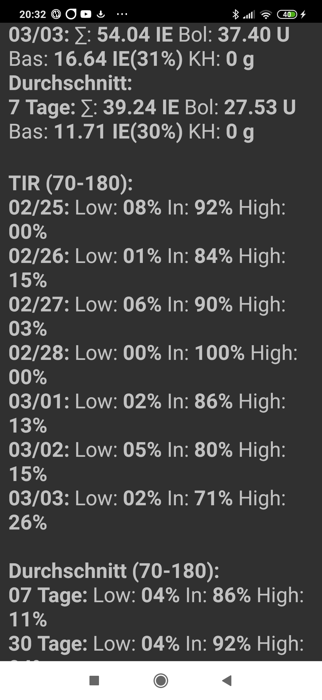



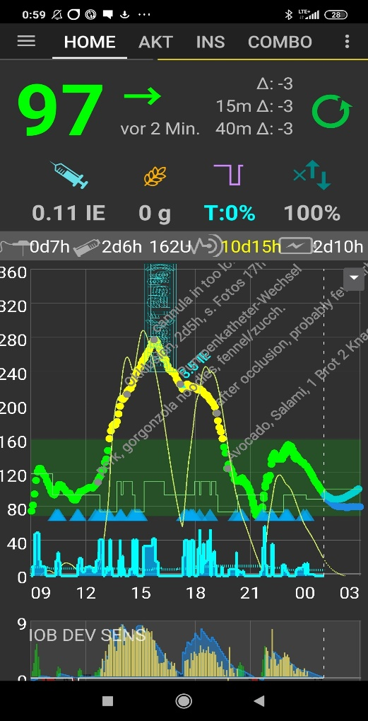

Compare amount of dinner carbs vs. lunch carbs that the full loop *suspects*)*!

and correction iob

*) fake carb deviations from fake

The occlusion led to about 6 hours (13– 19 h = 25% of a day) above-range, which also affects the weekly (minus ~ 5%) and 30 day (minus 1%) TIR.

Rule of thumb: Per one occlusion (which can happen at any time, but is very likely to happen for many people after 48 hours of cannula (or pod) time), you easily lose 25% TIR that day, minus 5% TIR on the week, and still minus 1% TIR on the month!

Conclusions

Looping algorithms rely on precise iob figures. What the pump „says“ it send out, must completely arrive, and remain, in your body to become active during the „DIA“ period, in the pattern as given by the insulin model you set for the insulin you use.

Unfortunately, we frequently see reports that users of Lyumjev or of Fiasp suffer from side-effects from the additives. There is a tendency for **hematoma and occlusions** can **threaten the function of the full closed loop**.

It is therefore very important to have an eye on the time a **cannula (or pod)** is in use (many find **48 hrs** to be the **limit** *!*), and whether hard-to-explain glucose rises happen at ever increasing „fake“ iob (even before a 48 hr routine replacement).

In loopers‘ sites you can also find reports on adjunct problem solutions – also to reduce pain from injections -, like switching to a different cannula design, switching to U200 insulin, or mixing insulins.

Pod users may have a particularly hard time to keep things working sufficiently well.

In case you managed in the past only by employing Automations (or dynamicISF) „against“ day-to-day fluctuating „insulin sensitivity“ owed to increasing occlusion tendencies by day of pod use: It is not advised to build FCL with autoISF on such shaky grounds.